MPloyed

*A*

***Minor Project Synopsis***

*Submitted*

*In partial fulfilment*

*For the award of the Degree of*

***Bachelor of Technology (CSE-CT & IS)***

***In Department of Computer Science & Engineering***



Submitted By: Supervisor: Submitted to:

Sanchit Bhatnagar (160101241) Sushant Jhingran Dr. Nitin Rakesh

Harshita Sachdeva (160101118) Asst. Professor HOD (CSE)

**Department of Computer Science and Engineering**

**Sharda University, Greater Noida**

**January 2018**

**TABLE OF CONTENTS :**

**1. Abstract………………………………………………………………………………………..3**

**2. Introduction…………………………………………………………………………………... 4**

**3. Feasibility Study……………………………………………………………………………… 4**

**4. Requirement Analysis………………………………………………………………………... 5**

**5. Proposed Modules…………………………………………………………………………….6**

**6. Conclusion…………………...………………………………………………………………..7**

**7. References.…………………...………………………………………………………………..7**

**ABSTRACT**

In the current scenario, there is a rat race in each and every professional field. The same holds true for the job market. Our Job Portal is an application that has been sincerely dedicated so as to seek/compile/gather online information about recruiters as well as the job seekers.

Our job portal has been designed in such a manner that helps both the job seekers and the recruiters in finding the right organization for the employees. In the case of job seekers, according to their educational qualifications, experience, and their respective preferences - wherein the job seeker himself can find and apply for their targeted job. In addition, to the recruiters, provides the suitable candidate from a pool of lacks thereby creating a win-win for both the parties.

Therefore, our job portal would be a perfect online arena, where the job seekers and the employers find their goal in the pursuit of getting a top-notch company for the suitable candidates.

**1. INTRODUCTION**

Our MPloyed application is a Multi-Platform mobile application which allows applicants and employers to register their own respective details. Applicants can browse through the vacancy details that are posted and can apply for the suited jobs online according to the area selected. It includes a filter search facility for the job seekers according to their required Locations.

Sending resumes saves effort, time and cost of the job seeker. All the vacancies are available on a single interface job seeker thereby easing out the communication between the job seeker and the employer.

**2. FEASIBILITY STUDY**

The main purpose of feasibility analysis is to check the economic viability of the proposed system. The result of the feasibility study will indicate whether to proceed with the proposed systems or not. If the results of the feasibility study are positive, then we can proceed to develop a system otherwise, the project should not be pursued.

**3. REQUIREMENT ANALYSIS (SOFTWARE & HARDWARE)**

* 1. ***HARDWARE REQUIREMENTS:***
     1. Android Device:

4.1.1.1 RAM: 2 GB or higher

* + - 1. Android Version : 6.0 or higher
    1. IOS Device:
       1. IOS Version: 10.0.2 or higher

4.1.3 Computer Device:

* + - 1. RAM: Minimum – 4Gb Recommended – 6Gb
      2. Graphic memory - 2Gb recommended
      3. Windows 7 or higher Or Ubuntu or Mac OS
      4. Storage Requirements – 10Gb
      5. Processor- Any processor with minimum 1 GHz processing speed.

***4.2*** ***SOFTWARE REQUIREMENTS:***

* + 1. React Native CLI
    2. Expo XDE
    3. Node.js
    4. Text Editor

***4.3 PREREQUISITES:***

* + 1. Basic JavaScript Knowledge
    2. Advanced ReactJS Knowledge
    3. React Native Knowledge
    4. Knowledge for Applications in Android and Android Studio
    5. Knowledge of Applications in IOS Devices

**4. PROPOSED MODULES**



* **Welcome Screens Module :**

This set of screens will be swipe able and

Will give an overview of what the app is for

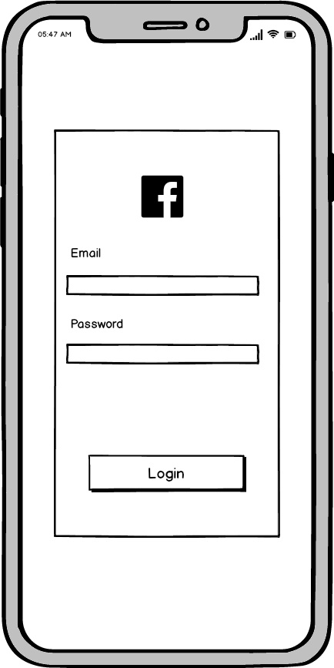

* **Facebook Auth Screen :**This screen will perform Facebook

Authentication to login user to the app



* **Map Screen :**

This screen will show a map from which

The user can choose and search list of jobs

From chosen location

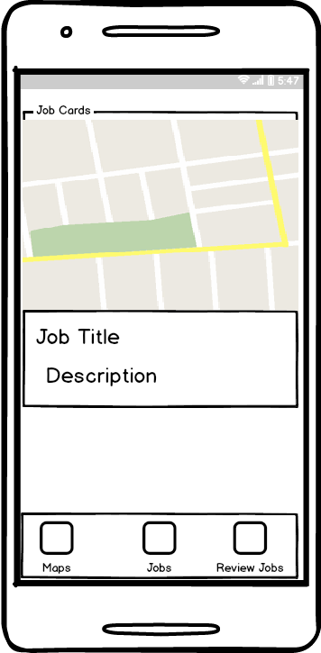

* **Jobs List Screen:**

This screen fetches list from API and

Shows jobs from the chosen location.

Jobs are saved by swiping right and

Ignored by swiping left.

* 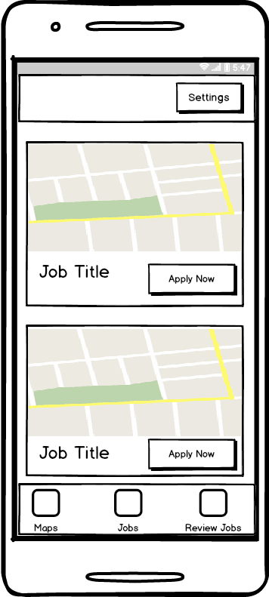**Review Screen :**

This screen shows saved jobs and users

Can go to company’s job portal to apply

To their jobs

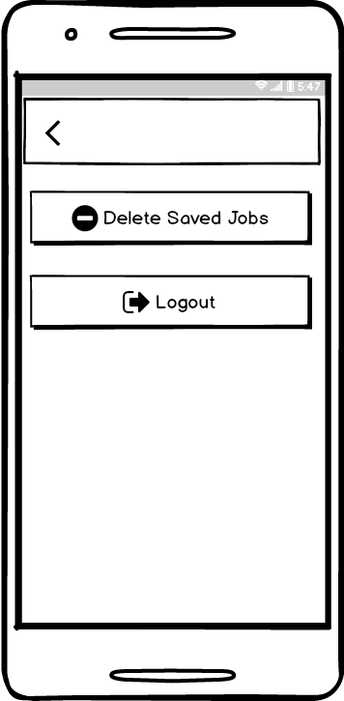

* **Settings Screen :**

This screen has 2 buttons:

Logout: Logs out user and returns to

Welcome screen

**5. CONCLUSION**

An easy maintenance of records of various Recruiters (Companies), job and job seekers has been maintained. To check for the detailed prospective, the jobseekers can do so through quick search provided in the portal. An attempt to prevent and reduce human error.

Reduced manual work. Classic functionality focuses on data storage. In addition, it also outlines the means to retrieve and analyse data to extract, transform, load and process data.

**6. REFERENCES**

***Toolkits:***

[1] Node Package Manager - <https://nodejs.org/en/>

[2] Expo XDE - <https://docs.expo.io/versions/latest/introduction/installation>

[3] React Native CLI - <https://facebook.github.io/react-native/docs/getting-started.html>

[4] Sublime Text Editor - <https://www.sublimetext.com/3>

***Websites for Reference:***

[1] Expo XDE Docs - https://docs.expo.io/

[2] React Native - <https://facebook.github.io/react-native/>